Pages 48-49 and 58 - 61 ***Java Programming A Comprehensive Introduction***

**Define**

Symbol ( % ) in java programming basic arithmetic- It is called a modulus which gives remainder of the integer.

20 % 3 = 2 ( for this modulus will be between 0-2)

Logical Operators

**& -** It resembles the multiplication, to be true, both side has to be true.

**-** It is same as addition. To be false both side has to be false.

**^ -** works as |, except it is “False” when both are same.

**-** use to separate two different argument, to run at least one argument has to be true

**&& -** use to separate two or more arguments, to run, all statements has to be true.

**! –** Not equal to

Difference between & and &&? &- verify both operands, while && stop evaluating if first operands is false since the result will be false

**Logic Table**

|  |  |  |  |  |  |
| --- | --- | --- | --- | --- | --- |
| **P** | **Q** | **P &Q** | **P Q** | **P ^ Q** | **!P** |
| **FALSE** | **FALSE** | **FALSE** | **FALSE** | **FALSE** | **TRUE** |
| **TRUE** | **FALSE** | **FALSE** | **TRUE** | **TRUE** | **FALSE** |
| **FALSE** | **TRUE** | **FALSE** | **TRUE** | **TRUE** | **TRUE** |
| **TRUE** | **TRUE** | **TRUE** | **TRUE** | **FALSE** | **FALSE** |

Programming Assignments- Attach Snipping Photos of source code and output for each separate programming task.

Task 1-

Write a program that converts Seconds into minutes.

Use the **new** Scanner (System.in); method and allow the user to input the number of seconds she wants to convert.

Use the modulus arithmetic symbol for part of the calculation/conversion.

**Output=** Show number of seconds input, conversion to minutes, and remaining seconds.

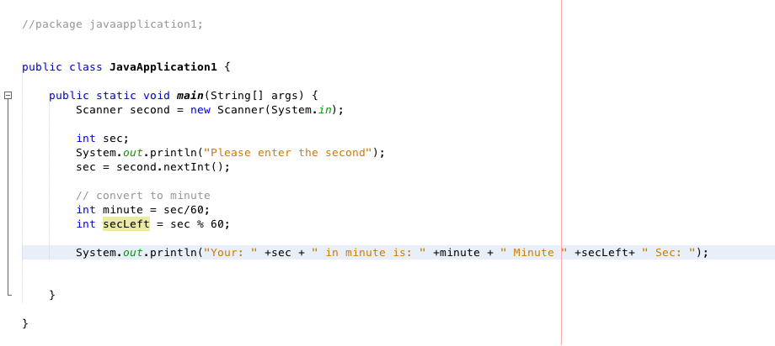

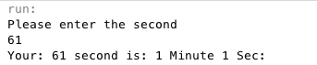

Task 2- We are going to enhance our Seconds to minutes conversion program from Task 1.

Use the **new** Scanner (System.in); method and allow the user to input the number of seconds she wants to convert.

We now want the program to calculate hours, minutes, seconds up to one day.

We will use (**if)** conditional statements and code blocks to create the program. (No need for if/else or anything else we have not covered in class to this point. But feel free to use if/else if you are comfortable with its application.)

**Output=** Show number of seconds input and a conversion to Hours, minutes and remaining seconds. Or have a print line for any input in seconds > than 1 day.

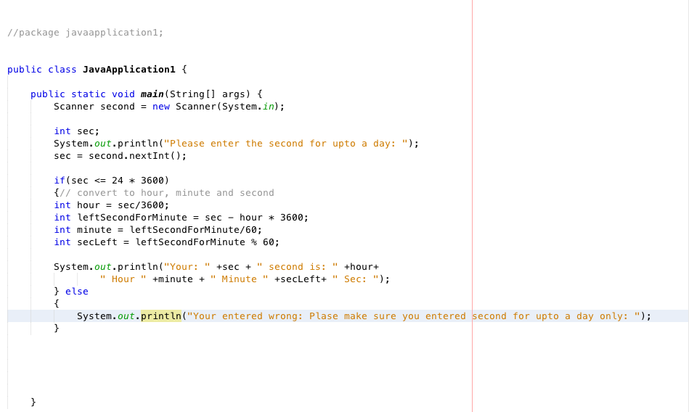

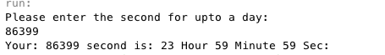



Task 3-

**boolean** leapyear = (year % 4 == 0 && year % 100 != 0)

(year % 400 = 0)

Use the statements above in your program.

Connect the two statements above with a short-circuit operator, make sure code is correct, and create a program where the user can enter an integer year using the **new** Scanner (System.in); method and be returned a true if the year is a leap year or false if the year is not a leap year.

**Sample Outputs**

**“Enter Year”** // User prompt

**2000**

**“2000 is a leap year? true”** // Output

**“Enter Year”** // User prompt

**190**

**“190 is a leap year? false”** // Output

